A Resource on Chamorro Catholics from the United States Conference of Catholic Bishops (USCCB)

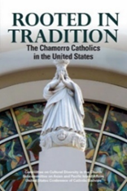

Rooted in Tradition: The Chamorro Catholics in the United States (for copies contact scapa@usccb.org)
A people indigenous to the Mariana Islands in the western Pacific, the Chamorros have a strong Catholic heritage, which they brought with them to the United States. This portrait of the Chamorro Catholics in the United States reveals the character and strength of their Catholic faith.

